Abstract Title

#First Author ¹, Second Author ²
¹ First Affiliation, First Country
² Second Affiliation, Second Country
Email: xxxxxx@yyyyy.zzz Corresponding Author’s address

This document is provided so that the author may simply type over it to produce an Abstract for ICCF25. The entire document should be in Times New Roman Font with single-line spacing. The title should be in 14-pt bold, author names and the affiliation in 12-pt. Put a star (*) before the corresponding author and provide the email address. The heading of the title, author name and affiliation should have only the initial letters capitalised.
The abstract paper size is A4, with 2.5 cm for the left, right, top and bottom margins. The document should be one page long with one column. The body text must be in 11-pt regular. The abstract text should be left and right justified.
Figure captions should be below the figures; table heads should appear above the tables. Insert figures Fig. 1 and tables Table 1 after they are cited in the text.

Number | Data (°C) | Uncertainty (°C)
1. | 11 | 2
Table 1 Example of a table caption (10 pt Times New Roman within the whole Table)

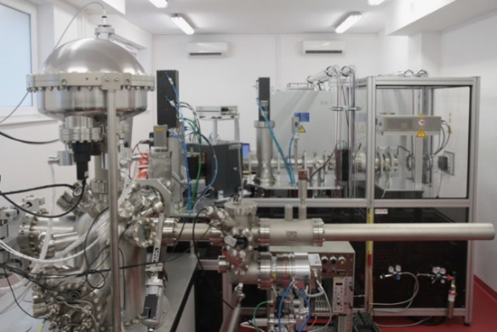
Fig. 1 Example of a figure caption (10 pt Times New Roman)

Equations: Number equations consecutively. Be sure that the symbols in your equation have been defined before or immediately following the equation.
(1)
Indicate references (if present), using sequential numbers enclosed in square brackets, e.g. [1].

Abstracts are to be submitted electronically in Adobe pdf document format not exceeding 10 MB. Submissions are to be made on the ICCF25 website (https://www.iccf25.com/) by choosing the Abstract Submission tab. Author needs to pre-register to upload the abstract. The deadline for abstract submission is April 1st, 2023.

References numbers for citations should be put after the abstract in square brackets [X].
[1] A. Author, B. Author, Journal Name, vol. XX, no. NN (Year) pp. 000-999
[2] A. Author, B. Author, C. Author, Book Name, N-th edition, Publisher, Place (Year) pp.000-999.

